RIVER HALLADALE - SALMON CONSERVATION 2026

GENERAL POLICY

In recent years, due to the continued decline in returning salmon numbers to British waters, Atlantic Salmon were reclassified on the IUCN Red List as endangered. In light of this, Fisheries Management Scotland have recommended that a 100% catch and release policy be implemented throughout Scotland for both salmon and sea-trout.
On the Halladale, we have already seen anglers apply voluntary return rates of 98% in recent seasons, demonstrating their commitment to conservation and it is greatly appreciated that the vast majority of our guests return all their fish when possible. As such, we believe that all anglers will be supportive of our new policy, detailed below, which heavily promotes the return of all fish.

BY COMING TO FISH THE HALLADALE, YOU AND YOUR PARTY AGREE TO ABIDE BY THE FOLLOWING CATCH AND RELEASE CODE. Please make sure your party fully understand their responsibilities. If you have any queries, please speak with Reuben Sweeting the River Manager.

CATCH AND RELEASE CODE FOR 2026

Spring Salmon until the 13^{th of} June 2026

All fish caught up to the 13^{th of} June must be released. Should the fish not survive its capture and die, it will become the property of the estate. In this case Reuben Sweeting should be notified. This rule brings the Halladale in line with what has become established practice on most Scottish Rivers.

FROM 14th JUNE TO 30th SEPTEMBER
A maximum of one fish per beat week is permitted to be retained.
Additional safeguards: -
- no fish over 60cms (5lbs) may be kept.
- No hen fish to be retained.
- All stale or coloured fish MUST be returned.

The only exception to the above guidelines concerns badly bleeding fish which will not survive being returned to the river, but these will count as fish taken. Deeply hooked fish will survive if the cast is cut and fish returned with fly /hook which they will normally get rid of rapidly.

GLOBAL WARMING AND FISH SURVIVAL

We remain deeply concerned about the adverse effects of climate change on the Halladale as a salmon fishery. In recent years, the water temperature at Weedies has reached 25℃ on several occasions, an unwelcome record not witnessed before and one that is critically dangerous to salmonids at all life stages. In an increasing number of rivers in the UK fishing is being paused when critical river temperatures are reached and, as implemented in 2023, if the River Manager considers the water temperatures to be too high, we shall require our guests to cease fishing. This stance has been further supported by The Marine Directorate who have issued similar advice on the cessation of fishing during high water temperatures. We hope this will be an infrequent event and, regrettably have decided we will not be able to compensate our clients for lost fishing time should the situation arise. We hope you share our view that in the interests of stock conservation this is a sensible precaution.

EQUIPMENT

The fishing tackle used should be strong enough to enable the fish to be brought in quickly taking account of the prevailing conditions and the possible size of the fish that might be caught. Anglers MUST follow best practice and carry a suitable rubber meshed landing net and be competent in its use.

NO TREBLE HOOKS at all to be used. Barbless hooks are recommended.

Rubber meshed landing nets: No tailers, No gaffs. Rubber meshed landing nets are now required as they minimise damage to the fins and scales of the fish, and in light of the continued occurrence of Red Skin Disease and Saprolegnia across the country, we request that anglers adopt the use of rubber meshed nets. Replacement net bags can be purchased from Reuben or from Snowbee.

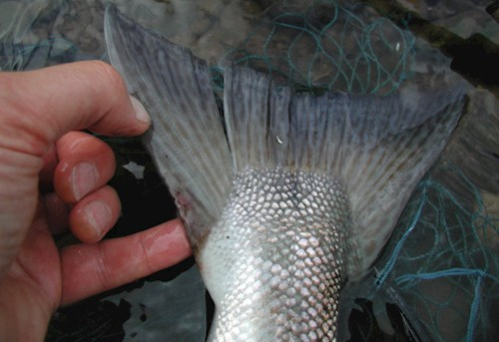

Large mesh landing nets can cause damage to fins.
Beaching fish which damages the mucous covering on fish scales and encourages infection MUST be totally avoided.

All fishers must carry suitable forceps for removing the hook and be competent in their use.

RECOMMENDATIONS

LANDING AND RELEASING FISH

Bring the fish to the bank firmly and quickly. We urge you not to lift the fish out of the water by any means if it is at all possible. At the very least, never lift your salmon from the water by its tail, or gill cover - you will cause internal damage. Never place fish on the bank or drag them over stones or gravel. If you do have to remove it use a net or support the fish on its side with both hands so as not to put excess strain on its spine or belly. Handle carefully – abrasion and loss of scales could lead to infection.

REMOVING THE HOOK

Wet your hands and keep the fish in the water.

Be gentle – don’t squeeze the fish!
Take extra care with fresh fish as they are more prone to scale loss, injury and subsequent fungal infection.

Use forceps to remove the hook gently.

If the fish is deeply hooked cut the cast as close to the hook as possible – these fish will survive.

REVIVING THE SALMON

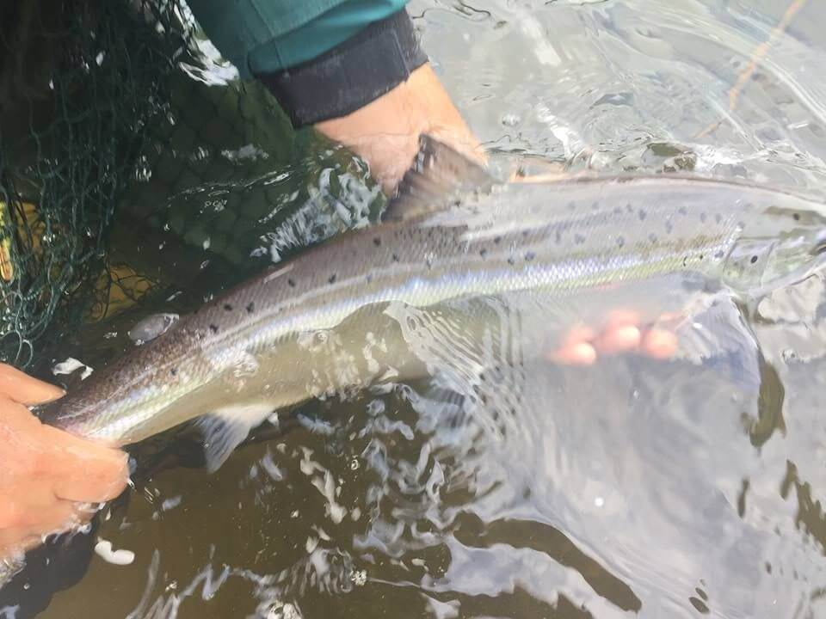

Support the fish gently facing into the current.

Be patient – the fish needs your help but minimal handling.

Let the fish recover and swim away on its own.

MEASURING THE WEIGHT

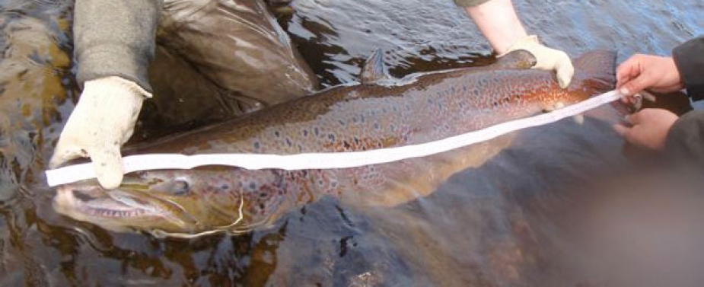

If measuring fish, keep them in the water and handle with care. Length to weight guides are posted in all fishing huts.
Only the use of rubber meshed weigh nets are permitted.

PHOTOGRAPHY:
Fish can be seriously damaged or even killed when photographing your catch. Do not place a live fish on the grass, gravel or stones for a photograph and do not keep it gasping in the air. Instead, keep the fish in or briefly just above the water. With wet hands, support the fish gently under the belly and loosely hold the wrist of the tail. The survival of the fish undamaged should be your first consideration at this moment and the photograph is of secondary importance. When water temperatures are high, fish should not be photographed under any circumstances.
KEEP FISH WET!

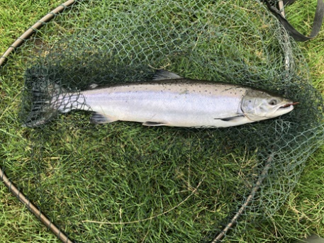
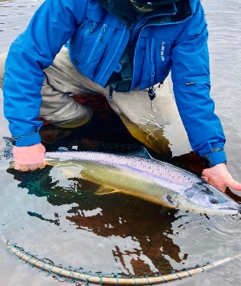
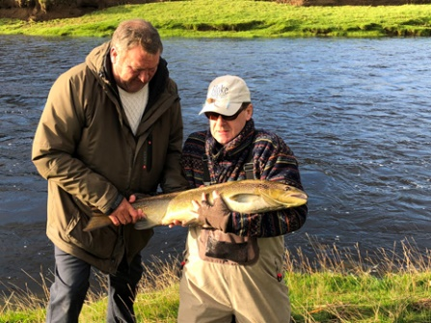
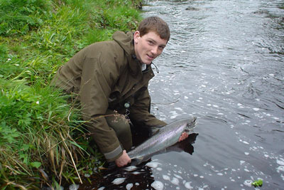



Saprolegnia
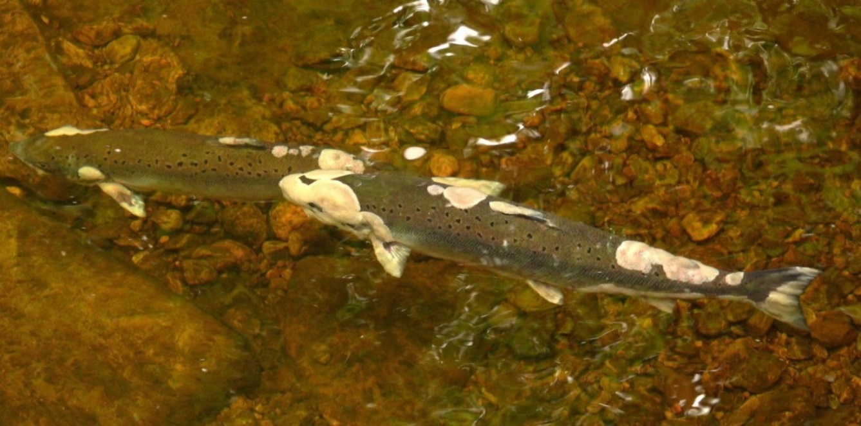

In response to the discovery of a new, more deadly strain of Saprolegnia in rivers throughout the country which is clear now to be a primary pathogen for fish - as opposed to the secondary infection - and can transmit from river to river, all anglers are required to disinfect their fishing equipment before and after use. These measures represent a sensible precautionary step and one that is likely to become best practice across the UK.
Disinfection stations will be found outside at the Strath Halladale Partnership accommodations for anglers and their party members to use. Parties staying elsewhere are required to contact Reuben Sweeting to arrange the use of a disinfection station.
Virkon disinfectant is the recommended treatment for equipment and has been used for many years for protection against Gyrodactylus salaris. Virkon is noncorrosive and safe to use on non-porous surfaces but if any guests have concerns equipment can be rinsed in clean water 30 minutes after disinfection.
A general guide to disinfecting equipment is outlined below:
- Remove all visible organic material/dirt.
- Apply the disinfectant to all surfaces to be treated, using footbaths where provided for boots and spray bottles for waders, nets, etc.
- Rinse with clean water after 30 minutes, if necessary.
If you have any questions regarding either the Saprolegnia or the increased biosecurity measures, then please contact Reuben Sweeting on 07920 571026 who will be happy to assist.

Any fish that are caught or seen with Saprolegnia infections should be reported to Reuben immediately and to Fisheries Management Scotland via this app https://survey123.arcgis.com/share/d7bfc35ca216442d95e4456b37c35a94?open=menu

GYRODACTYLUS SALARIS

HAS ANYONE IN YOUR PARTY FISHED ABROAD THIS YEAR?

IF SO, ACTION MUST BE TAKEN TO DISINFECT THEIR KIT BEFORE FISHING ON THE HALLADALE.

A declaration that action has been taken where necessary signed by the person accepting the offer to fish on the Halladale must be e mailed to Sarah Kerr or Reuben Sweeting before fishing starts.

THE PARASITE

Gyrodactylus salaris is a freshwater parasite which is fatal to many strains of Atlantic Salmon and can be carried by other strains, particularly those in the Baltic and White sea areas which are tolerant to it.

FATAL TO SCOTTISH SALMON

In Norway salmon stocks in over twenty major rivers have been wiped out by inadvertent introduction of the disease. Tests have shown that it is fatal to Scottish Salmon. It is essential that the disease is not introduced here.

FOUND IN EUROPE

The disease has been positively identified in Russia, Norway, Sweden, Finland, the Baltic States, Denmark, France, Portugal and Spain. It may also be present in Iceland, Holland and Belgium. At present only the UK and Ireland are free of the disease.

CAN LIVE IN WET CLOTHING AND TACKLE

The parasite is very hardy and can survive out of water in wet conditions in clothing, boots, and fishing equipment including flies, nets, lines, reels and plastic bags.

THESE MUST BE DECONTAMINATED BEFORE USE ON THE HALLADALE IF ANY OF YOUR PARTY HAVE FISHED ABROAD THIS YEAR

All the above equipment must be decontaminated before use on the Halladale.

a) Notify Reuben Sweeting (07920 571026) the River Manger who can advise and help on what to do

b) thoroughly clean all fishing equipment and clothing and either: -

- Put it all in a freezer for 24hours.
- Dry for 48 hours at 21C (70F)
- Heat for at least one hour at 60C (140F)
- Immerse in a special solution harmless to clothing and equipment for a minimum of ten minutes.

